BUCKLANDS BEACH YACHT CLUB INC.
HAUL OUT APPLICATION 2022
Office Hours Monday – Friday 0900-1700hrs. Telephone 534-3046, reception@bbyc.org.nz
P.O. Box 54-005, The Marina, Auckland 2144

Owners Name |  |  |  |  |  | BBYC member no |  |  | Phone no
Address: |  |  |  |  |  |  |  |  | Work:
Email: |  |  |  |  |  |  |  |  | Mobile:
Desired Date for Hauling: |  |  |  |  |  |  | Desired Date for Re-launch
 |  |  |  |  |  |  | Confirm with Graeme Fearnley 027 6499144 on week before
Vessel’s Name |  |  |  |  |  |  | Type or Class
Length: |  |  |  | Draft: |  |  | Beam: |  |  |  | Approx. Weight:
Has the owner hauled a boat at BBYC before?: |  |  |  |  | YES/NO |  | Is mast or engine lift intended? |  |  |  |  |  |  | YES/NO
Has owner used intended cradle before?: |  |  |  |  | YES/NO |  | Is spray painting or antifouling intended? |  |  |  |  |  |  | YES/NO
 |  |  |  |  |  |  | Is water blasting intended |  |  | (Refer rule 9.05) |  |  | YES/NO
Insurance company:  Proof of Insurance required |  |  |  |  |  |  | Vessel’s Insured Value:
Cradle: Do you have a cradle (either owned personally or arranged privately)? Yes / No
- If Yes, please name the person providing it so Haulout can check its suitability. _______________
- If No, Haulout will use its best endeavours to source a cradle on loan for you and will be in touch.

Enclosed | Deposit $50.00
Declaration:
- I declare that I have a current, fully paid for the entire financial year, membership of the Bucklands Beach Yacht Club Inc; and
- I have read and understood the Haul Out Rules on the attached pages: and
- I have read and carefully viewed the Haulout safety video on the BBYC website which explains the procedures which must be followed; and
- I acknowledge that the Bucklands Beach Yacht Inc. is not responsible for any loss or damage to my boat arising from hauling out, re-launching or storing of my boat or equipment; and
- I agree that I am totally responsible for the suitability of the cradle for my boat, the correct set-up of the cradle and for the security of the boat in the cradle at all times (both during hauling, whilst on the hardstand and re-launching); and
- I agree to pay all dues prior to launching.

Signed: |  | Name (Print):
Boat: |  | Witness:
Date: |  | Witness Name:

FOR OFFICE USE ONLY:
Deposit of $50 received on / / Signed
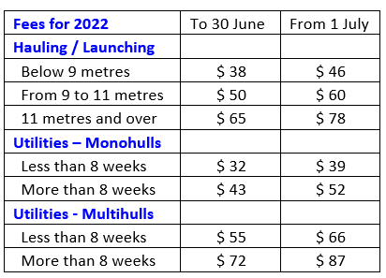
Haul Date | / / |  | $
Launch Date | / / |  | $
Elapsed time (weeks) |  |  | $
Period weeks @ | $ |  | $
Weeks @ | $ |  | $
Auckland Council Coastal Recovery Levy |  |  | $ 5.00
Total |  |  | $
Less Deposit Paid |  |  | $
TOTAL TO PAY |  |  | $

