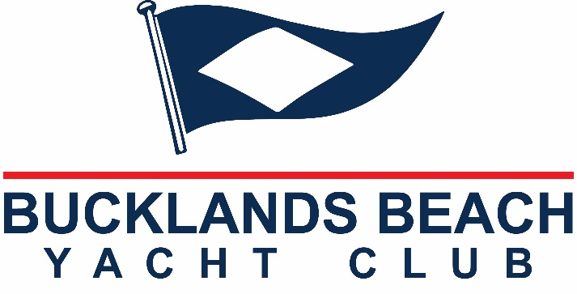

KEELER DIVISION

SEASON ENTRY: - Valid 1st OCTOBER 2020 1st OCTOBER 2021

Friday Afternoon Rum Race and Major Rum Races $500

Mid-Week Series, Winter Series, Single Handed,
Two handed, Saturday Series and Cruising Series $400

Season Entry to all Above Events $800

*Please note that you will still be required to complete a Notice of Race for each
event you intend to participate in by the specified time limit. Boats are only eligible for prizes if they have competed in that race or series.

Boat Name: ____________________________________ Sail No. _________________

Class / Design: _________________________________ LOA (mtrs) ______________

Owner’s/Skipper’s Name: _________________________ Ph: (AH) ________________

Address: ______________________________________ Mobile: ______________

I am a member of the ________________Yacht Club. Email:_____________________________

Please charge my credit card account Visa / MasterCard / Amex (please circle)
A/c No.
Expiry Date /
or pay by direct credit remit to:- Westpac Howick 03 0166 0029030 00

