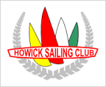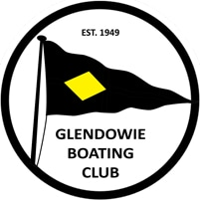

EAST AUCKLAND SERIES
14 March, 2021
ENTRY FORM
To: Bucklands Beach Yacht Club, P O Box 54 005, The Marina, Auckland 2144.
Ph: (09) 5343046 Email: manager@bbyc.org.nz

Boat Name: |  | Sail No.
Class/Design: | Opti Open  Opti Green  Starling  Starling Dev.  Other
Owner’s/Skipper’s Name: |  | Ph: (Home)
Address:
 |  | Mobile:
I am a member of | Yacht Club | Email:

Entry Fee: | Single Handed | $10.00 | FOR OFFICE USE ONLY
 | Double Handed | $15.00 | Received $
 | Total $ |  | Date / /

I declare that I am a current member of an affiliated YNZ Club.
I agree to be bound by the Racing Rules of Sailing and all other rules that govern this series and that competitors participate in the regatta entirely at their own risk. I understand that neither the Organising Authority and its officers, members and servants or other persons assisting with the conduct of the series accept any responsibility in respect of any injury, or loss to person or property that may be sustained by reason of participation in the series or however arising in connection with the series.

I agree to the use of my photograph(s) and other relevant information in any event publicity and in the ongoing promotion of New Zealand yachting. I agree to the Organising Authority and Yachting New Zealand holding the above information for the general administration and well-being of the sport, and for them to retain, use and disclose the information to affiliated organisations, and any other persons or organisations that Yachting New Zealand believes will further the interests and objectives of Yachting New Zealand. I acknowledge my right to access to and correction of this information. The consent is given in accordance with the Privacy Act 1993.

Signed |  | Owner/Skipper | Dated | / /

If you are under 18 years of age please provide guardians signature
Signed |  | Parent/Guardian | Dated | / /

